|  |  |
| --- | --- |
| **Student’s Name:** Zyrelle Cuizon | **Year/Section:** 3B JAVA |
| **Instructor’s Name:** Ryan teo | **Date:** February 1, 2024 |

**STUDENT ACTIVITY SHEETS**

AP 5 TECHNOLOGY AND THE APPLICATION OF INTERNET OF THINGS

ACTIVIY NO.2

Give at least 5 examples of IOT projects and discuss how it works.(include pictures of it)

1. **Smart Home Animation -** This involves connecting various home appliances and systems (lighting, heating, security cameras, etc.) to the internet so they can be controlled remotely via smartphones or automatically adjusted with smart algorithms. For example, a smart thermostat learns your schedule and preferences to optimize heating and cooling, reducing energy consumption. Sensors detect occupancy or the ambient temperature, and actuators adjust the settings of the HVAC system accordingly.

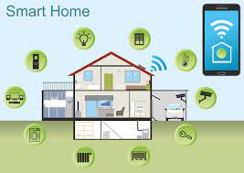

1. **Wearable Health Monitors -** Devices like fitness bands and smartwatches collect health-related data such as heart rate, steps walked, and sleep quality. This data is sent to a smartphone app or cloud server for analysis, providing insights into the user's physical well-being. For example, if a heart rate monitor detects an abnormal heart rhythm, it can alert the user and suggest consulting a healthcare provider.

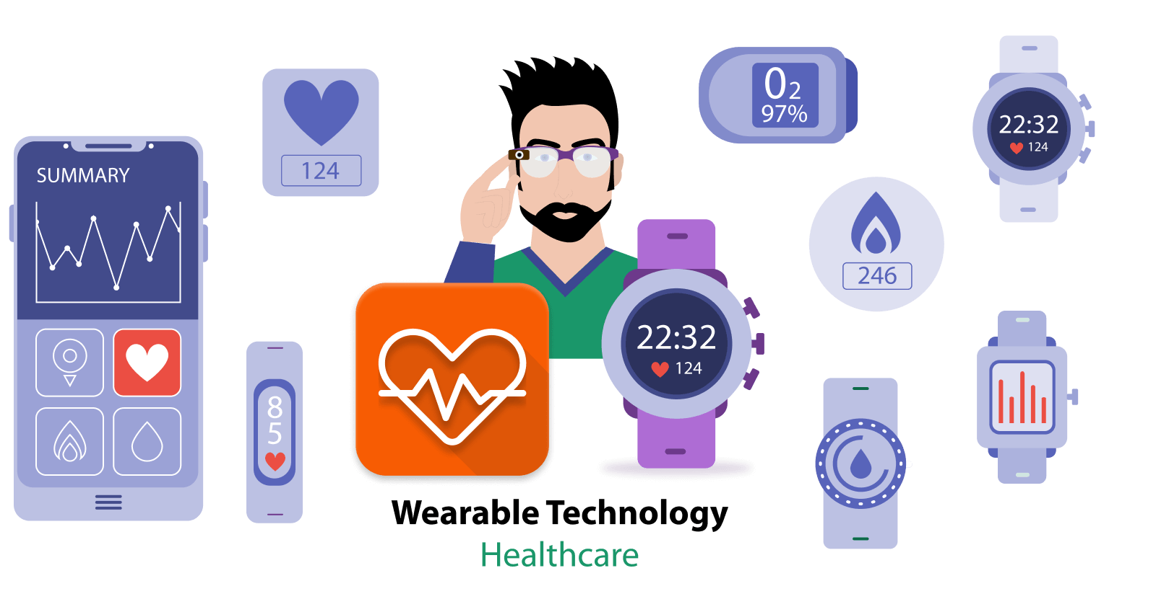

1. **Precision Agriculture -** IoT in agriculture involves using sensors to monitor conditions like soil moisture, crop health, and weather data. This information is used to optimize irrigation, fertilization, and pest control, improving crop yields while conserving resources. Drones and autonomous vehicles might be deployed to apply water or fertilizers precisely where needed, based on the data collected.

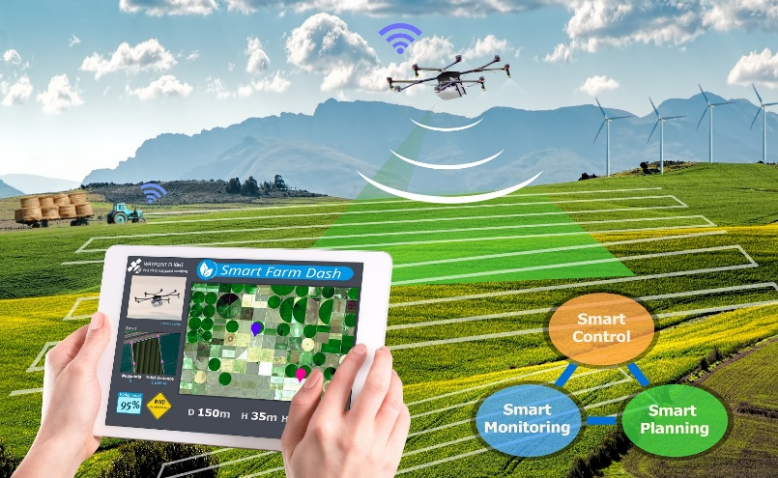

1. **Smart Grids -** IoT technologies are used to enhance electricity grid management by collecting data on consumption, supply, and operational conditions from smart meters and sensors distributed across the grid. This data helps utility companies balance supply and demand, detect and respond to outages more quickly, and integrate renewable energy sources more effectively. For instance, during peak demand, a smart grid could automatically adjust the supply or temporarily shut off non-critical loads to prevent outages.

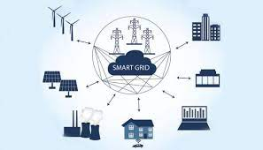

1. **Industrial IoT (IIoT) and Predictive Maintenance -** In manufacturing, IoT devices monitor machinery and equipment conditions in real-time. Sensors collect data on vibration, temperature, and other indicators of wear or impending failure. This data is analyzed to predict when equipment might fail, allowing maintenance to be performed just in time to prevent downtime without unnecessary routine checks. This approach increases efficiency, reduces maintenance costs, and extends the lifespan of industrial equipment.

